COSMETOLOGY REGIONAL AND STATE

All of the following images below will be selected for the Cuts and Style contest at all Tennessee Regional and State Cosmetology Competitions 2019

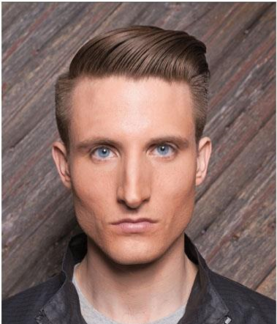 |  | 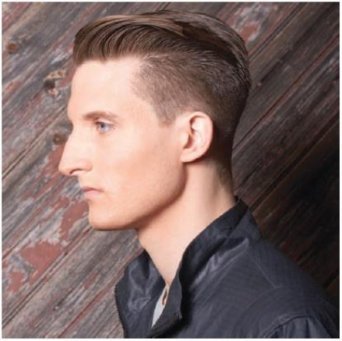 | Men’s Cut: Technical can be found in Pivot Point’s Meta: MEN – Page 106
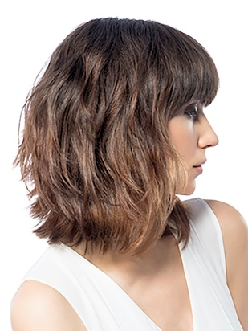 |  |  | Ladies Cut: Technical can be found in the  Milady Standard Haircutting System –  Mid-Length Layers – Page 98

